Name : Dhavalkumar Vijaykumar Patel
Subject : Essential of Cyber Security and Cyber Waefare
Class : M.Sc Cyber Security
Semester : 1

Lab 8 :

Packet Sniffing in Windows
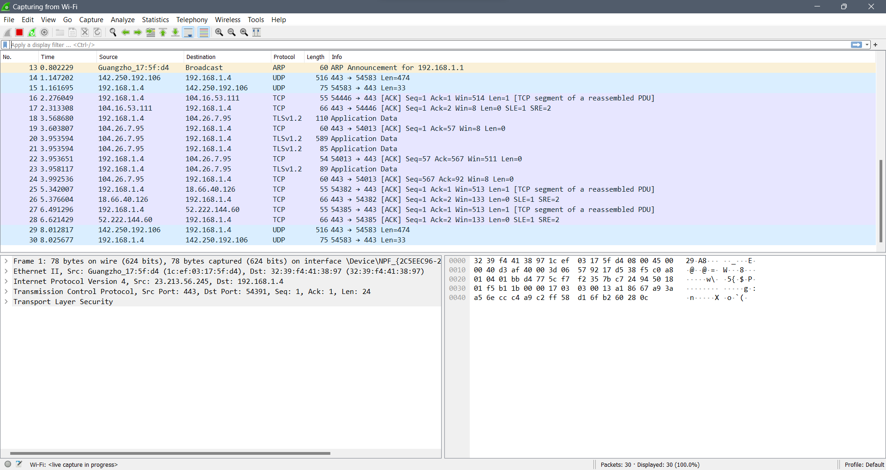
Packet sniffing in Linux
